Name: Yash Sasane

Division: F(F4)

PRN: 202201050052

Roll No: 681

Practical No.2

Input file:

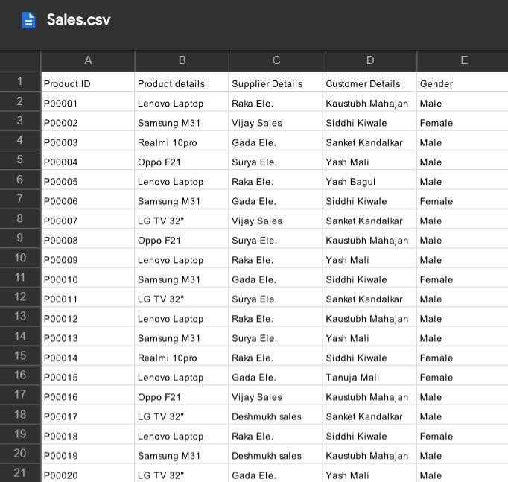

Code:

1. Read csv file into python data structure

|  |
| --- |
| Product_details = []  Supplier_details = dict() Customer_details = [] #tuple() gender={} fp1 = open("/content/drive/MyDrive/Colab Notebooks/Sales.csv","r") data = fp1.readline() while(True):  data = fp1.readline() if not data: break; #print(data) data = data.replace("\n","") temp = data.split(",")  Product_details.append(temp[1])  Customer_details.append(temp[3])  Supplier_details.update({temp[0]:temp[2]}) gender.update({temp[3]:temp[4]})  fp1.close()  #print(type(Customer_details))  Customer_details = tuple(Customer_details) print(type(Customer_details)) |

Output:

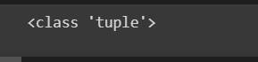

print("\nProduct_details\n",Product_details,end="") print("\nCustomer_details\n",Customer_details,end=""

)

print("\nSupplier_details\n",Supplier_details,end=""

) print("\nGender_details\n",gender,end="")

Output:

1. Find the

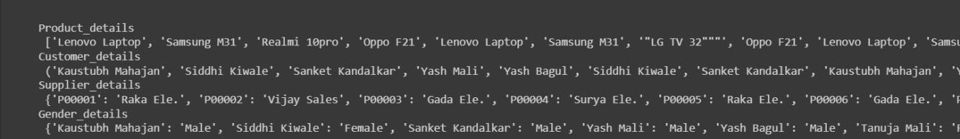 most popular product for sales

|  |
| --- |
| frequency = {} # {Lenovo Laptop : 3}  #Iterating over the list for item in Product_details:  #checking the element in dictionary if item in frequency: #incrementing the counter frequency[item] += 1 else:  #intializing the counter frequency[item] = 1 #printing the frequency  print(frequency)  marklist = sorted(frequency.items(),key = lambda x:x[1], reverse = True) sortdict = dict(marklist) print(sortdict) print("The most popular product for  sales",list(sortdict.keys())[0],"sold",list(sortdict.values())[0],"time s") |

Output:

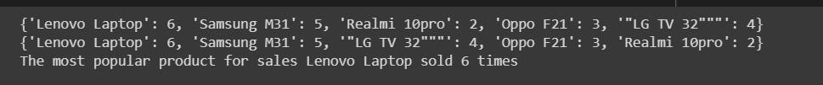

**OR**



|  |
| --- |
| from collections import Counter counter = dict(Counter(Product_details))  sorted_counter = sorted(counter.items(),key = lambda x:x[1], reverse = True) sorted_counter = dict(sorted_counter) print("The most popular product for  sales",list(sorted_counter.keys())[0],"sold",list(sorted_counter.values ())[0],"times") |

Output:

best supplier for sales

|  |
| --- |
| frequency = {}  #Iterating over the list for item in Supplier_details.values(): #checking the element in dictionary if item in frequency: #incrementing the counter frequency[item] += 1 else:  #intializing the counter frequency[item] = 1 #printing the frequency print(frequency)  marklist = sorted(frequency.items(),key = lambda x:x[1], reverse = True) sortdict = dict(marklist) print(sortdict) print("The most popular Supplier for  sales",list(sortdict.keys())[0],"sold",list(sortdict.values())[0],"Item s") |

Output:

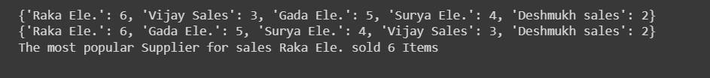

**OR**

from collections import Counter counter =

dict(Counter(list(Supplier_details.values())))

sorted_counter = sorted(counter.items(),key = lambda x:x[1], reverse =

True) sorted_counter = dict(sorted_counter) print("The most popular Supplier for

sales",list(sorted_counter.keys())[0],"sold",list(sorted_counter.values ())[0],"Items")

Output:

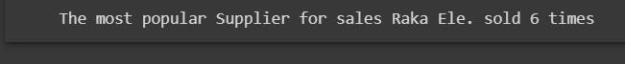 customer who buys most of the products

|  |
| --- |
| frequency = {}  #Iterating over the list for item in Customer_details:  #checking the element in dictionary if item in frequency: #incrementing the counter frequency[item] += 1 else:  #intializing the counter frequency[item] = 1  #printing the frequency print("Frequency is as below: \n",frequency)  marklist = sorted(frequency.items(),key = lambda x:x[1], reverse = True) sortdict = dict(marklist) print("\n Sorted dict is as below: \n",sortdict) print("\n\n The customer who buys most of the  products:",list(sortdict.keys())[0],"buy",list(sortdict.values())[0],"I tems") |

Output:

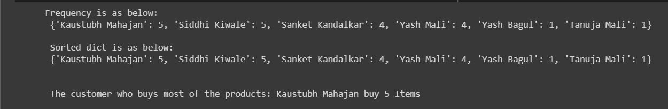

**OR**



from collections import Counter counter = dict(Counter(list(Customer_details)))

sorted_counter = sorted(counter.items(),key = lambda x:x[1], reverse = True) sorted_counter = dict(sorted_counter) print("The customer who buys most of the products:",list(sorted_counter.keys())[0],"buys",list(sorted_counter.va lues())[0],"Items")

Output:

number of customer who are 'Female'

|  |
| --- |
| #Identifying unique customers    from collections import Counter counter = dict(Counter(list(Customer_details))) names = list(counter.keys()) print(names) male=0 female=0 for name in names:  if gender[name]=="Male": male  = male + 1 if gender[name]=="Female":  female = female + 1  print("Total no of Males:",male) print("Total no of Females:",female) |

Output:

